Freedom To Change Minutes – October

10/06/2025

Meeting was opened with the serenity prayer, 12 Traditions and 12 Concepts for NA Service.

Roll Call

☒Chair- Lydia F ☒ Treasurer- Russ K ☒ Registration- Shawna C
☐ Alt. Chair- Vacant ☐ Alt. Treasurer- Vacant ☐ Alt. Registration- Vacant
☒ Sec- Clayton M ☒ Hotel/Hospitality- Cobey C ☒ Programming- Steve G
☐ Alt. Sec- Vacant ☐Alt. Hotel/Hosp Vacant ☒Alt. Prog- Sheri R
☐ Merch – Paige W ☒ Activity- Kris O
☐ Alt. Merch-Vacant ☐Alt. Act- Vacant
Guests
Hilary K

Subcommittee Reports

Chair- Lydia F.____________________________________________
September Meeting Minutes – Motion to approve and seconded.

Alt. Chair- Vacant

Treasurer- Russ K__________________________________________

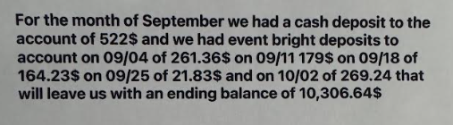
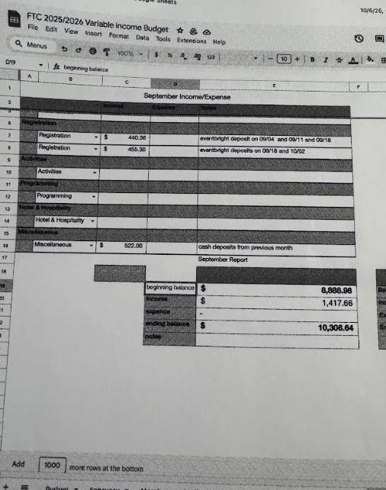
Alt Treasurer- - no report

Secretary – Clayton M______________________________________
No Report
Alt. Secretary- Vacant

Programming- Steve G______________________________________
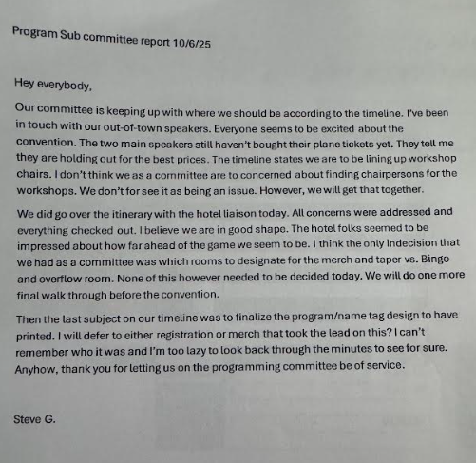

Alt. Programming- Sheri R - none

Merchandise- Paige W________________________________________

48 Orange Hoodies
24 Black Shirts for Trunk or Treat
Hilary selling shirts at region this weekend.
Merchandise Committee Report - October 6th, 2025
Prepared By: Paige W., Merchandise Chair

Here is a summary of the Merchandise Committee&#39;s activities and progress since our last report.
Recent Sales &amp; Events
● Show Me Regional Meeting: The committee still has the option to attend the upcoming
Show Me Regional Meeting in October for additional potential sales opportunities.
● September 8th Shirt disbursement:
○ Cobey C. Sale: Cobey C. sent the Merchandise committee $100 from the sale of
5 shirts via Cash App.
○ Have not received any other funds for sales or notification of sales from other
trusted servants.
○ If sales have been generated, Trusted Servants should provide those funds to Russ
Treasurer.

● Current Funds: The Merchandise committee currently has $310 in the money bag. This
includes $70 from cash on hand, $100 from Cobey C.&#39;s sales, and $140 from other sales
made by the committee.
● Inventory of Presale shirts: 24 shirts in on-hand inventory w/o shirts that have been
distributed to Trusted Servants of FTC.

Current Projects
● Items for Trunk or Treat Event: The committee is currently working on items for the
Trunk or Treat Event, specifically Halloween hoodies.
Halloween Hoodies/Merchandise
The committee is exploring options for Halloween-themed merchandise. Based on
communications with Austin, we have the following choices:
● Option 1: 50 hoodies for a total of $1087.50.
● Option 2: 48 hoodies and 24 shirts, totaling $1,219.50. This option would save the
committee $1.75 per hoodie on printing and provide more inventory for the Trunk or Treat
event, with a price difference of $122.10.
The Merchandise Committee is proposing 48 Orange Hoodies and 24 Green Shirts with the same

print as the design for Option 2 if the committee approves Option 2.

Pending Items
● Lanyard/Badge Design: We are still waiting for the QR code for the convention schedule
to finalize the lanyard and badge design.
That concludes our report for this session. We are continuing our efforts to sell our pre-event
merchandise and are moving forward with planning for the main convention.

Design For Trunk or Treat Merchandise


*If we approve option 2, for green shirts, the orange area in the image above will be green!!

Alt. Merchandise – Vacant

Activities- Kris O____________________________________________
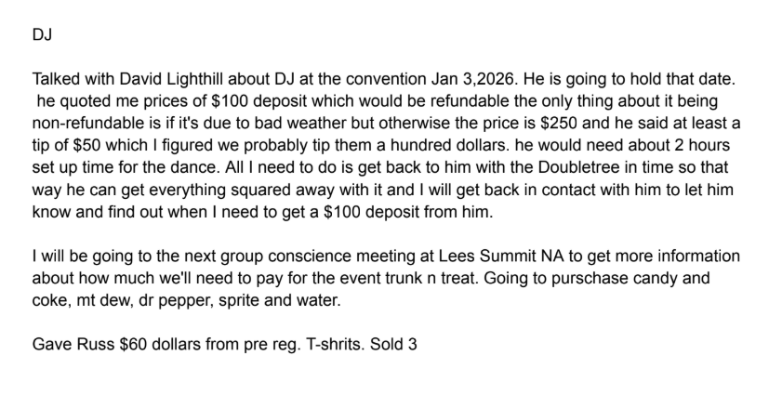
Alt. Activity- Vacant – No report

Hotel and Hospitality- Cobey C________________________________

Alt. Hotel and Hospitality-Vacant
Registration - Shawna C______________________________________

Registration price increasing on December 13th to $30
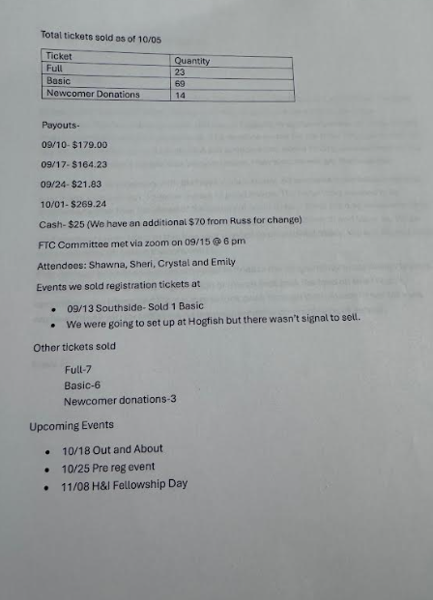
Alt. Registration- Vacant

Open Positions:
Alt Chair – Suggested Clean Time – 4 Years
Alt Treasurer – Suggested Clean Time – 4 Years
Alt Hotel and Hospitality – Suggested Clean Time – 2 Years
Alt Secretary – Suggested Clean Time – 1 Years
Alt Merchandise – Suggested Clean Time – 4 Years
Alt Registration – Suggested Clean Time – 4 Years
Alt. Activities – Suggested Clean Time – 2 Years

Old Business:
Hospitality Suite – Groups Hosting Dinner on Friday, Breakfast, Lunch and Dinner on Saturday, and Breakfast on Sunday, Banner all tabled until October meeting.

.
New Business: Nominations for Open Positions – None

Sharing Session

Motion to close submitted and seconded.

Minutes submitted by Clayton M.

Important Times and Dates
FTC Monthly Committee Meeting – First Monday 6:30pm 1001 Pacific St. KC, MO 64106
Programming Subcommittee – First Monday 5:30pm Opera House 500 Walnut St. KC, MO 64106
Registration Subcommittee – Third Monday 5:30pm Meeting on ZOOM Meeting ID 79200308628 PW B6iz1D
Hotels/Hosp Subcommittee – Third Tuesday 7:15pm No Matter What 722 Reynolds Ave KCK 66103
Activities Subcommittee – Last Wednesday 5:30pm Opera House 500 Walnut St. KC, MO 64106

